**Share on Social Media:**[Share event on Facebook](https://www.facebook.com/events/454585744895381/)[Share event on Twitter](https://twitter.com/CareerEco/status/870660700581933056)[Share event on LinkedIn](https://www.linkedin.com/groups/1193357/1193357-6276426861438386177)

**REGISTER** [**NOW**](https://www.careereco.com/events/caspa)**to attend the FREE Physician Assistant Virtual Fair on July 18th & 19th   
Connect real-time with 20+ PA Programs nationwide in a Live Event! (**[**Review List**](https://www.careereco.com/details/caspa)**)**

[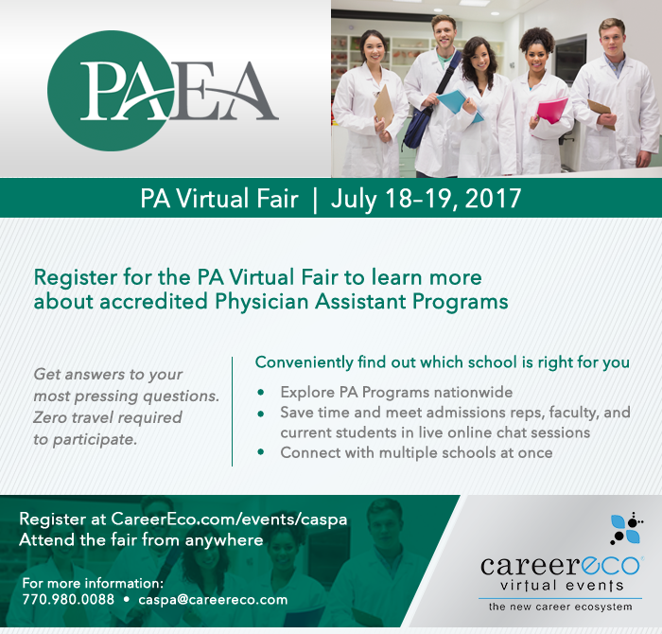](http://www.careereco.com/events/caspa)